`
Vulcan Activity Tracker
Weekly Report

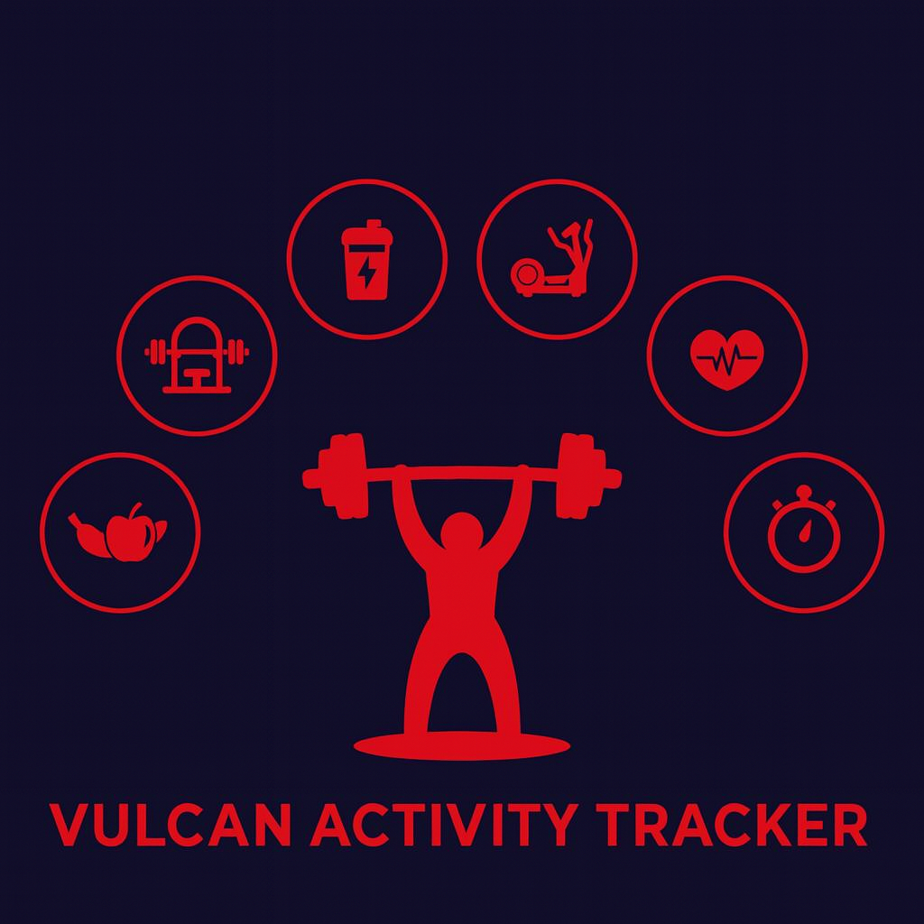

Week 14
Team Members:
Margo Bonal
John Gerega
Luke Ruffing

Professor: Dr. Weifeng Chen

Course: CMSC-4920-Senior Project II
School: Pennsylvania Western University

Table of Contents

Project: Vulcan Activity Tracker 1
Goals Accomplished: 2
Gantt Chart: 4
Member Contribution: 4

Project: Vulcan Activity Tracker
This report serves as the week 14 and final weekly report of Senior Project. While this semester has provided challenges, as a team, we feel like we are finishing the semester strong and completing our proposed goals. The Vulcan Activity Tracker transformed from concept to actuality in merely 14-week term. We believe we have produced a deliverable that is fully functional, meets proposed specifications, and represents our years at PennWest California well. We are proud of both group effort and ourselves for what it took to complete a large goal such as this. This not only motivates us for our final advisory board performance but also instills confidence in our abilities as we enter the next phase of upcoming graduation and job search.
During our final week of progress, our team prepared for the upcoming Advisory Board meeting. This included final debugging, user manual pick up from print shop, and timed demonstration practices.

Goals Accomplished:
Our senior project team successfully accomplished the goal of completing The Vulcan Activity Tracker. Revisions from week 13 presentation were made. When hovering over the top navigation bar, the words were changing to black, however they could not be seen on the big presentation screen even though visible on laptops. We changed this to hover color to be red so users can easily see what page they are navigating to. Overall testing was commenced to ensure components were properly working for demonstration.
Our team also held several practice presentations to cover slide revisions, documentation, and practice questions. While final presentation still needs improvement, we now have a good idea of how we want to organize and assign speaking roles. Testing and cost analysis has been additionally performed on the online hosted version of our application. Speed and efficiency options are being researched to reduce lag.
Challenges Faced:
Overall challenges of this week were running overtime during presentation practice and debugging components due to a lost merge of code. Code fixes were able to be resolved, hover, we are still working to perfect presentation time.
Solutions:
Team Progress:

Gantt Chart:
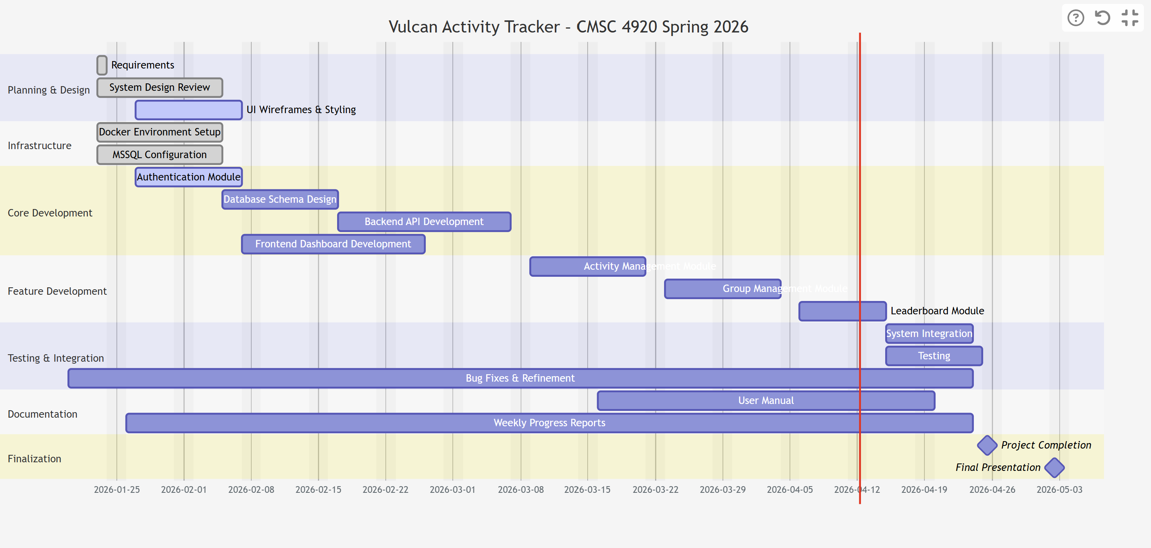

Member Contribution:

Team Members
Margo Bonal: | - Team meetings, Week 13 Report & Slides, User Manual
John Gerega: | - Team meetings, Week 13 Report & Slides, User Manual
Luke Ruffing: | - Team meeting, Week 13 Report & Slides, User Manual

